UMBERTO D. (1952)

*Umberto D*. is a film by Vittorio De Sica, which is often said to mark the end of the Italian neorealist film movement. Its modernism is expressed through its hybridity, unusual optics, and changing points of view. Dedicated to the political, economic, and moral rebuilding of Italy in the postwar period, neorealist films radically broke with earlier cinematic codes, emphasizing on-location shooting, unobtrusive editing, nonprofessional actors, and simple everyday narratives. Umberto D., a retired man, is threatened with eviction because of his failure to pay rent. He fakes illness, is hospitalized, and returns to find his bedroom destroyed and his dog missing. Umberto contemplates suicide, but decides against it because of his dog. Released towards the end of the movement, *Umberto D*. represents a more heterogeneous filmic approach through its use of obtrusive camerawork, subjective viewpoints, and meta-cinematic moments. While the first neorealist film, *Roma città aperta* (*Rome Open City*, 1945) by Roberto Rossellini, reflected solidarity and hope for a promising new social order, *Umberto D.* represents the failure of these hopes as it depicts characters who remain disconnected and unable to understand one another. At the same time, the film comments on, refers to and utilizes other filmic styles, such as melodrama, and other media, such as *fumetti,* or “photonovels”. Since socio-political critique is filtered through popular art forms, and subjective rather than objective neorealist aesthetics, the film suggests that the ethical and political goals of the neorealist movement can be achieved through other cinematic modes.

*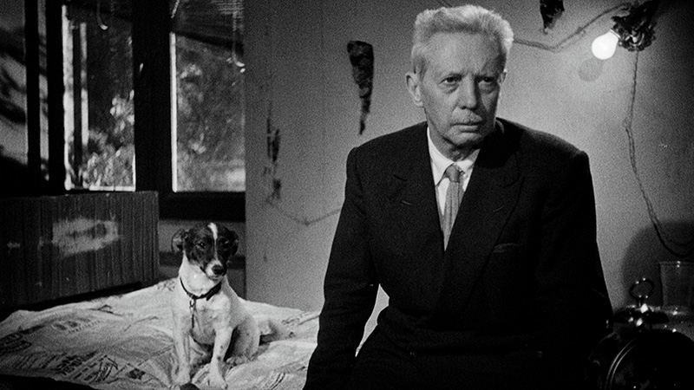*

<http://www.criterion.com/current/posts/292-seeing-clearly-through-tears-on-the-smart-sentiment-of-umberto-d>

References and further reading:

Bondanella, P. (2001) *Italian Cinema from Neorealism to the Present – Third Edition,* New York: Continuum.

Marcus, M (1986) *Italian Film in the Light of Neorealism,* Princeton: Princeton University Press: 96-117.

Young, V. (2000) ‘*Umberto D*.: Vittorio De Sica’s ‘Super’-Naturalism’ in reading’ in Howard Curle & Stephen Snyder (eds.) *Vittorio De Sica Contemporary Perspectives.* Toronto: University of Toronto Press: 198-203.

Paratextual Material:

Criterion Collection Trailer

<http://www.criterion.com/films/371-umberto-d>

Photos and Images  
<http://www.filmtv.it/film/7498/umberto-d/foto/>

Maria Alexandra Catrickes  
Yale University